Multi-Sensor Anomaly & Condition Monitoring Project

Abstract

This project analyzes industrial machine sensor data to detect anomalies and monitor machine health. It uses statistical techniques, SQL analysis, and machine learning models to identify abnormal patterns in temperature, vibration, pressure, energy consumption, and production data.

Introduction

Industrial machines generate large volumes of sensor data. Monitoring this data helps in identifying potential failures early. This project focuses on anomaly detection and condition monitoring to improve machine efficiency and reduce downtime.

Objectives

• Detect anomalies in sensor data
• Monitor machine health
• Build condition index
• Develop dashboards for visualization
• Support predictive maintenance

Tools Used

• Python
• SQL
• Excel
• Power BI

Data Processing and Analysis

Steps performed:
• Data cleaning and prepossession
• Statistical anomaly detection
• SQL analysis for machine performance
• Data exploration using Python

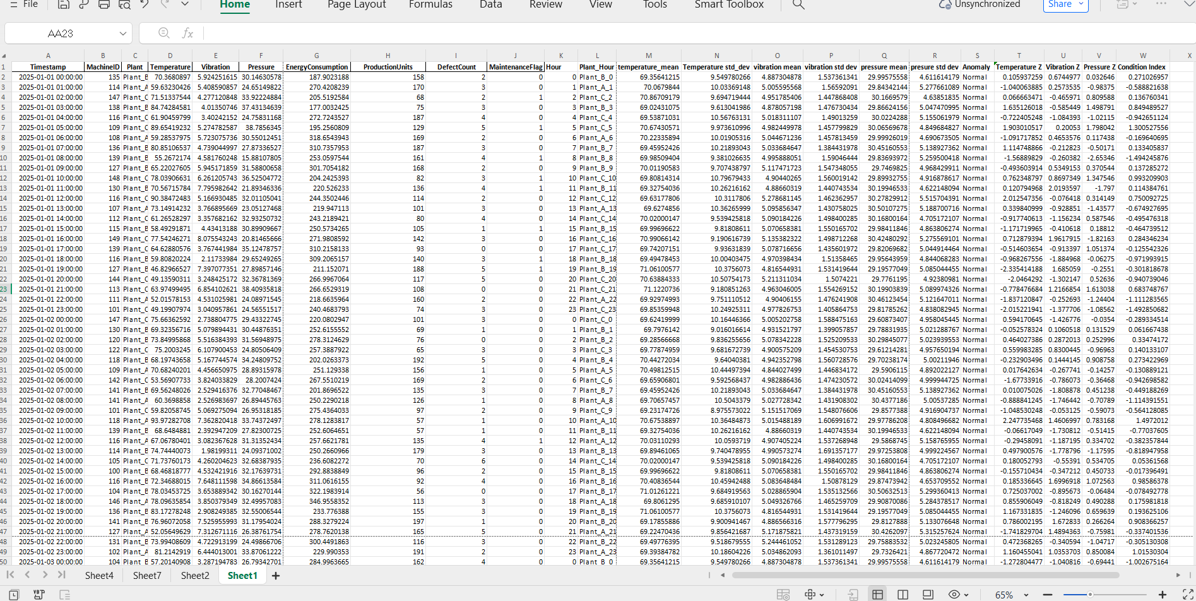
SQL Analysis

1.Objective
To analyze sensor data using SQL and identify anomalies and machine performance metrics.SQL queries are used to calculate average sensor values for each machine and plant.
The following metrics are computed:
• Average Temperature,Average Vibration,Average Pressure
These averages help identify deviations that may indicate abnormal machine behavior.
2.Anomaly Detection Using SQL (Q3)

Approach:
- Calculate Mean (AVG) and Standard Deviation (STDDEV) for each sensor:
  - Temperature
  - Vibration
  - Pressure

Output:
- Number of anomalies per:
  - Plant
  - Machine

3.Aggregated View Creation (Q4)

Objective:
Create a summarized dataset for machine performance.

Output:
- Clean summarized dataset
- Machines categorized as:
  - Critical
  - Normal

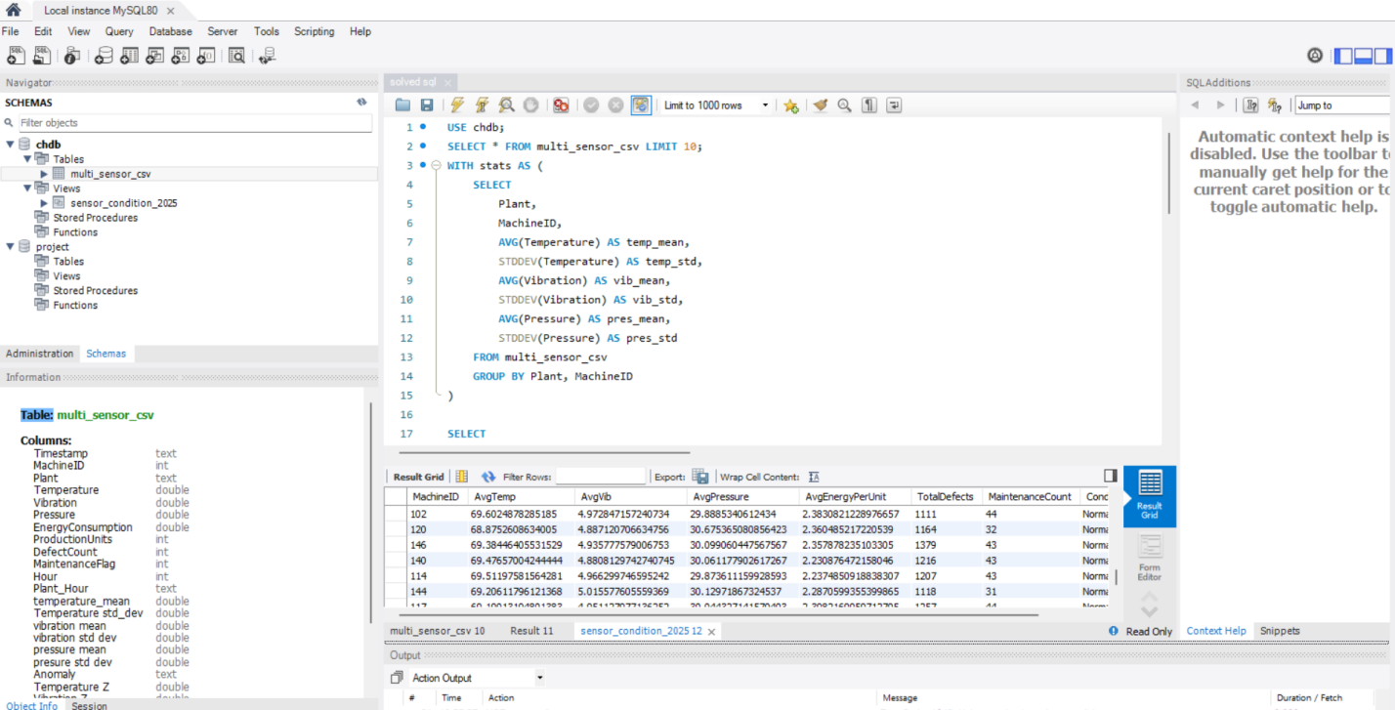

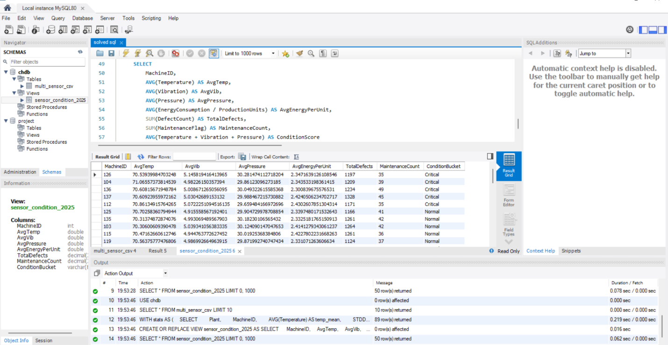
Python Analysis

1.Objective:
Detect anomalies using Machine Learning.The data-set is imported into Python using the Visual Studio Code environment.Using the Pandas library, the data-set is loaded and inspected to understand its structure, columns, and data types.

2.Anomaly Detection Using Python (Q5)

Method Used:
- Isolation Forest Algorithm

Steps:
- Load dataset using Pandas
- Select relevant features:
  - Temperature
  - Vibration
  - Pressure
  - Energy Consumption
  - Production Units
- Train Isolation Forest model
- Predict anomalies

Output:
- List of top 200 anomalies
- Includes:
  - Machine ID
  - Timestamp

3.Health Score Prediction (Q6)

Objective:
Predict machine health using regression.

Steps:
- Create HealthScore column
- Train regression model
- Evaluate model performance

Output:
- Predicted health scores
- Identification of key influencing factors
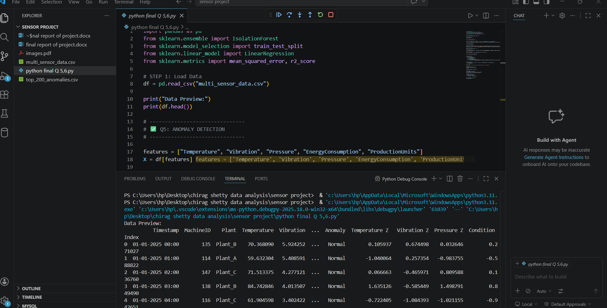

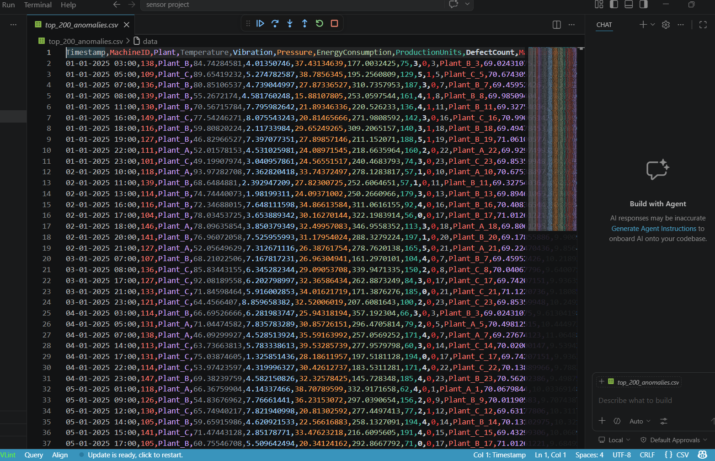
Sensor Monitoring Dashboard
The processed dataset is loaded into Power BI, where interactive visualizations are created to provide insights into machine health.
Key components of the dashboard include:
- Anomaly Count KPI to display the total number of detected anomalies
- Trend Analysis showing anomalies over time (daily basis)
- Machine Ranking based on Condition Index to identify poorly performing machines
- Slicers/Filters for:
  - Plant ID
  - Machine ID
This dashboard helps users quickly identify critical machines and monitor system performance effectively.

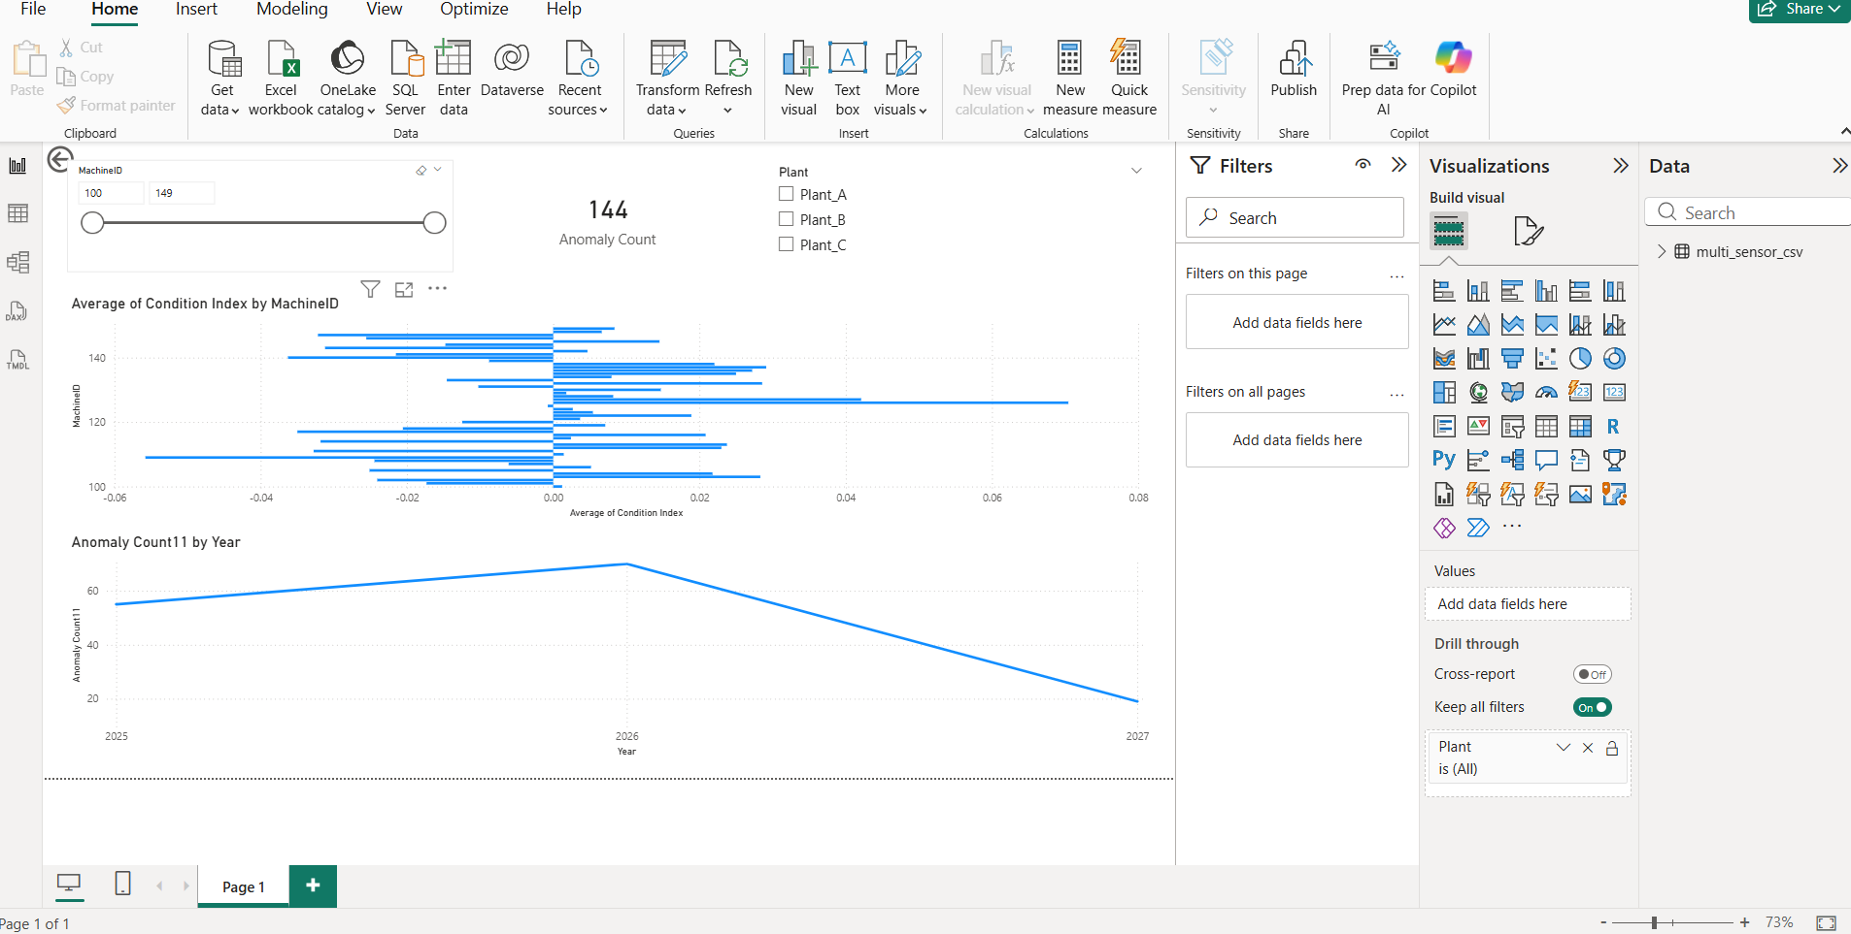

Interactive Condition Analysis

The dashboard includes synchronized visualizations for:
- Temperature trends
- Vibration patterns
- Pressure variations
Anomaly points are highlighted on the charts to clearly show abnormal behavior over time.
Additional features include:
- A detailed table displaying anomaly events
- Time-based analysis for deeper insights
- Interactive filtering for better exploration
This allows users to:
- Analyze sensor behavior over time
- Detect patterns and irregularities
- Support data-driven maintenance decisions

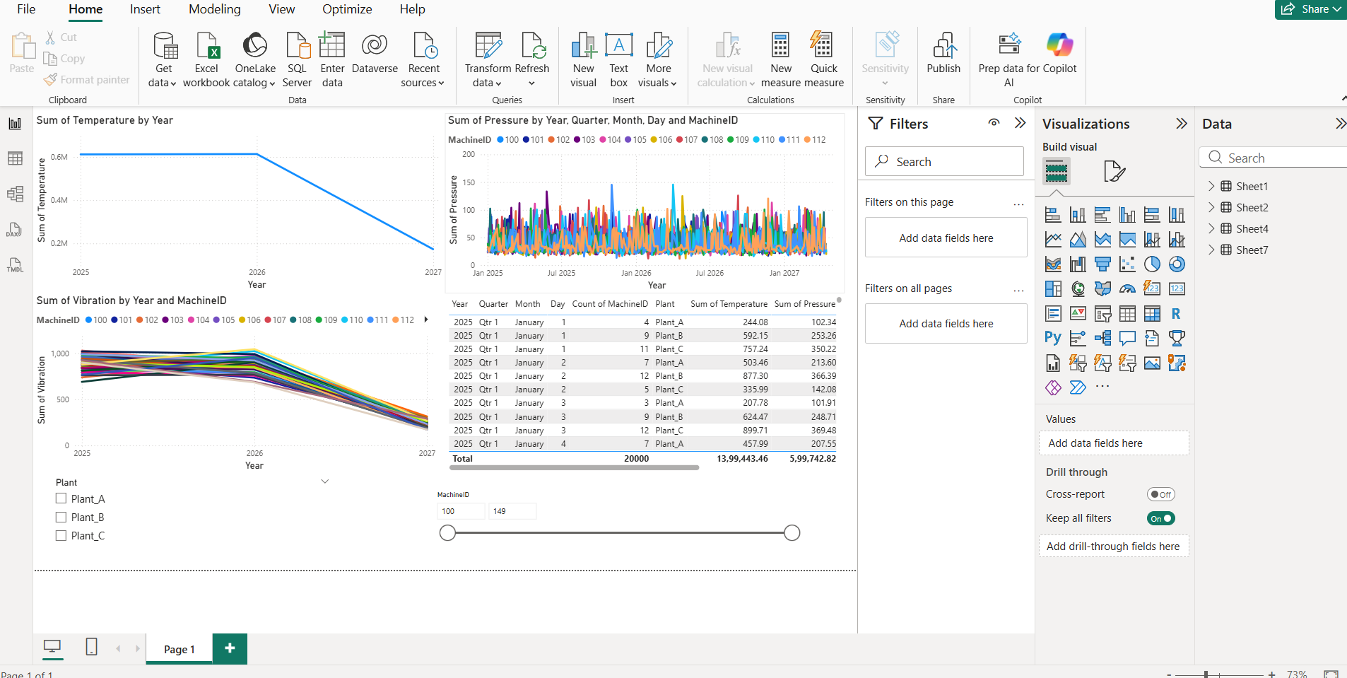
Project Outcome
This project shows how we can use data analysis and machine learning to understand machine sensor data and find unusual behavior (anomalies).
Instead of checking machines manually, the system automatically monitors their performance and alerts us when something is wrong.

Main Results:
- The system can automatically detect problems in machines
- It helps to check the health of machines easily
- Dashboards make it easy to see and understand data
- Decisions are based on data, not guesswork

Overall Benefit:
This helps companies fix issues before machines fail, reduce downtime, and improve efficiency in industrial operations.

